# Task 1

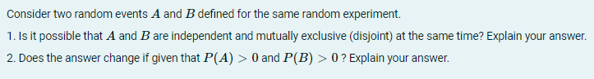

1. If and $B$ are independent events, then by definition $P\left(A∩B\right)=P\left(A\right)⋅P(B)$. But if A and B are mutually exclusive, then $A∩B=∅$, hence $P\left(A∩B\right)=0$. This implies that $A$ and $B$ can be independent and mutually exclusive only if $P\left(A\right)⋅P\left(B\right)=0$ or in other words if $P\left(A\right)=0$ or $P\left(B\right)=0$ (or both).

2. On the other hand, if $A$ and $B$ are independent events and $P\left(A\right)>0$, $P\left(B\right)>0$, then $P\left(A∩B\right)=P\left(A\right)⋅P\left(B\right)→P\left(A∩B\right)>0$. This implies, that $A∩B$ isn’t an empty set, thus events $A$ and $B$ can happen together and are not mutually exclusive.